UNIVERSITY OF

FOOD TECHNOLOGIES

PLOVDIV

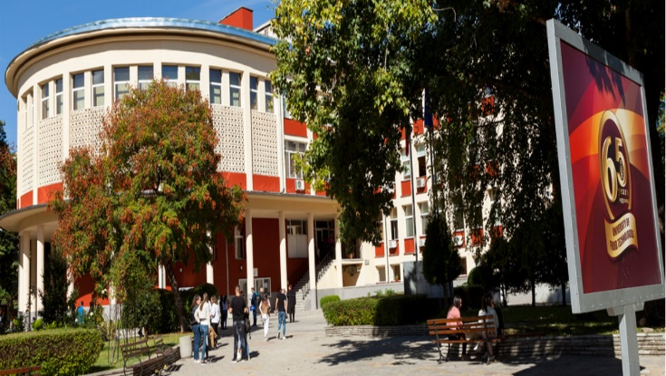

CALL FOR PAPERS

66TH INTERNATIONAL CONFERENCE

« FOOD SCIENCE, ENGINEERING
AND TECHNOLOGY - 2019 »

October 11 - 12, 2019
Plovdiv, Bulgaria

ORGANIZING COMMITTEE
CHAIRMAN:
Prof. Eng. Kolyo Dinkov, DSc
Rector of the UFT
DEPUTY CHAIRMAN:
Corresponding Member of Bulgarian Academy of Sciences Prof. Eng. Stefan Dragoev, DSc
Vice-Rector of the UFT on Research & Business Partnership
MEMBERS:
Prof. Eng. Nikolay Menkov, DSc
Prof. Eng. Albena Stoyanova, DSc
Prof. Eng. Iordanka Alexieva, PhD
Prof. Eng. Violeta Rasheva, PhD
Assoc. Prof. Eng. Venelina Popova, DSc
Assoc. Prof. Eng. Galin Ivanov, DSc
Assoc. Prof. Eng. Georgi Kostov, DSc
Assoc. Prof. Eng. Georgi Dobrev, PhD
Assoc. Prof. Atanaska Teneva, PhD
Assoc. Prof. Eng. Radoslava Gabrova, PhD Assoc. Prof. Eng. Kremena Nikovska, PhD
Assoc. Prof. Petya Nestorova, PhD
Assoc. Prof. Eng. Borislav Milenkov, PhD
TECHNICAL ASSISTANTS:
Eng. Adelina Bogoeva, PhD
Daniela Atanasova
Gergana Velcheva
Ivanka Kuneva
Magdalena Damyanova
Eng. Annie Sarahosheva
Eng. Daniel Hristozov
Eng. Rumen Stoilov
THEMATIC AREAS
1) FOOD SCIENCE AND TECHNOLOGY
- Science and Technology of Food of Plant Origin
- Science and Technology of Food of Animal Origin
- Food, Nutrition and Dietetics
- Science and Technology of Beverages
- Science and Technology of Tobacco Products, Perfumery and Cosmetics
2) FOOD CHEMISTRY, MICROBIOLOGY, BIOTECHNOLOGY AND
SAFETY
- Food Chemistry and Microbiology
- Food Biotechnology and Nanotechnology
- Food Analysis and Control
- Food Safety
- Ecology and Toxicology of Food and Biotech Industry
3) FOOD Process ENGINEERING
- Applied Mathematics and Statistics
- Applied Physics
- Mechanics of Food and Biotech Industry
- Process Engineering in Food and Biotech Industry
- Equipment for Food and Biotech Industry
- Energy and Energy Efficiency in Food and Biotech Industry
- Processes Automation of Food and Biotech Industry
- Electronics and Electrical Engineering Applicable in Food and Biotech Industry
- Computer Systems and Technologies of Food and Biotech Industry
4) CATERING, TOURISM AND ECONOMY OF FOOD INDUSTRY
- Catering
- Tourism
- Economics of Food and Biotech Industry
- Industrial Management of Food and Biotech Industry
- Linguistics and Learning

WORKING LANGUAGES: English and Bulgarian

REGISTRATION FEES

Early registration fee (for one report or poster) - payable not later than June 30, 2019

Delegates - lecturers and researchers - € 75

Delegates - PhD students or students - € 25

Accompanying persons - € 40

Participants without report - lecturers and UFT staff - € 25

Late registration fee (for one report or poster) - payable from July 1, 2019 to September 30, 2019:

Delegates - lecturers and researchers - € 100

Delegates - PhD students or students - € 40

Accompanying persons - € 50

Participants without report - lecturers and UFT staff - € 40

The registration fee covers: the Programme of the Conference, Books of Abstracts, Handouts, Coffee Break and Official Dinner Vouchers.

The registration fee should be paid via bank transfer to the UFT Bank Account.

Beneficiary: UFT, Plovdiv,
fee for SWUFT (number) Conference - 2019
IBAN: BG53CECB97903180002900
BIC: CECBBGSF
Bank: Central Cooperative Bank AD,
Plovdiv Branch

In the bank statement as additional information please indicate: the “SWUFT number” that you will receive when you upload the abstract of your report/poster, names and affiliation of the corresponding author.
If you need an invoice you must provide the following information when performing the payment:
- For universities, research institutes and companies - all data needed for the invoice in your country.
- For individuals - full names, personal identification number, and full address.

IMPORTANT DEADLINES
- June 30 2019 - registration and submission of applications, accompanied by a full text of the abstract, correspondence address and E-mail contact.
- July 15 2019 - Confirmation for acceptance of the report or poster by the Organizing Committee
- June 30 2019 – Deadline for the early registration fee payment.
- July 31 2019 - Submission of the full text of manuscripts (including tables and figures in Word .docx format)
- September 30 2019 – Deadline for the late registration fee payment

MANDATORY REQUIREMENTS FOR CONFERENCE PARTICIPANTS
http://scienwork.uft-plovdiv.bg/en/instructions

PUBLISHING REQUIREMENTS
There will be limited publishing of the manuscripts presented at the conference orally or as posters. In the journal Scientific Works of UFT 2019 and at the website of UFT - Plovdiv will be published only those manuscripts which have been approved of by the Editorial Board after peer-reviewing.

http://scienwork.uft-plovdiv.bg/en/vhod

PAPERS: FORMATTING REQUIREMENTS
Conference participants are expected to format their papers using the paper layout template and send it as a file attachment. Papers submitted for publication should be original and must not have been published elsewhere. They must be written using Microsoft Word 2010 or later version.

USE THE PAPER LAYOUT TEMPLATE AT:

http://scienwork.uft-plovdiv.bg/en/maket

We accept papers in English or Bulgarian.
Do not number the pages of the paper.
Manuscripts, which have not been formatted according to the requirements, will not be accepted.

CONTACT ADDRESS:

Scientific Conference 2019 University of Food Technologies (UFT) - Plovdiv
26 Maritsa Blvd.,
4002 Plovdiv,
Bulgaria

UFT website: www.uft-plovdiv.bg

Send your questions, opinions and recommendations to:

http://scienwork.uft-plovdiv.bg/en/question

